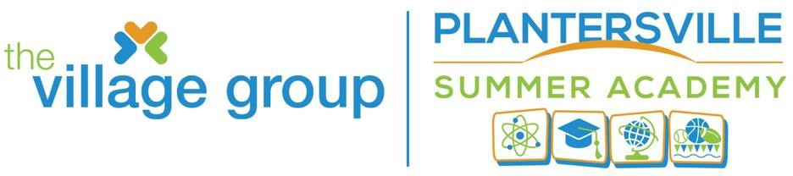

February 10, 2025

We are **HAPPY** to announce that as of February 10, 2025 registration will be open for our Plantersville Summer Academy and Summer Bridge Programs. Our Planning Team has been diligently working to provide our Scholars with another educational-fun-packed summer.

The summer programs will provide common core standards in Reading, Math, STEAM, educational/fun-filled field trips, and several other life-changing experiences.

We will begin on Monday, June 3, 2025, at Plantersville Elementary School on 1668 Exodus Drive, Georgetown, South Carolina.

The tuition cost per child is $240 {$40 per week} for the summer and a $30 nonrefundable registration fee. The costs of the field trips are not included. The total cost being paid by May 12, 2025.

**The tuition cost per child residing outside of the Georgetown County School District** is$300{$50 per week} for the summer, and a $30.00 non-refundable registration fee. The costs of field trips are not included**.** The total cost being paid by May 12, 2025.

We encourage you to complete and return the attached registration application as soon as possible. **Online registration will be available on February 10, 2025.** Please be reminded that students will be selected on a first-come-first-serve basis. Be sure to check our website for program updates <http://www.thevillagegroup.org/>

* Tuition Fee (June 3 -July 10, 2025) $240.00 **Must be paid in Full May 12, 2025**. Field trips are not included.
* May 13, 2025, the non-refundable registration fee will be $40.00

### Summer Swim Mini Camp is $35 (First come First served)

### Open House – May 1, 2025, at Plantersville Elementary School -5:30pm.

### Pre-Testing is required and will be administered during the 1st week of the Summer Academy, June 3-5, 2025.

### Field trips are being developed, dates and associated costs will be available by May 1, 2025.

### End of the Year Educational Tour for July 10-14, 2025- initial fundraiser will take place on May 1, 2025. Additional information will be provided ASAP

### Under the Federal Educational Rights and Privacy Act of 1974, The Village Group requires your signature of consent for the Student Record Release Form in the application.

### Thank you,

### Queen D. Funnye Program Director

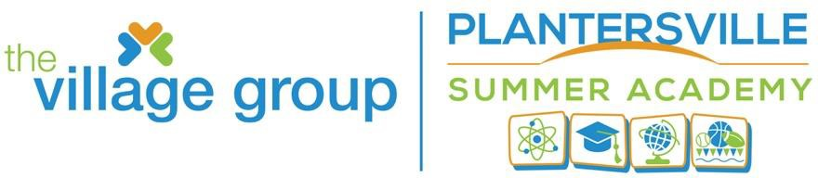

**2025 Student Registration**, **page 1/3** Date:

**Plantersville Summer Academy**

**(Please complete the entire registration form; incomplete applications will delay processing and possibly deny admittance into program**)

**Last Name First Name M.I.**

## Present Grade Level: ______________ Date of Birth

School attended during 2024-2025 school term

IEP Submitted: Yes No

T-Shirt Size (Check One) YS YM _YL S_ M L XL XXL___3XL

One T-shirt provided; *additional T-shirts are available for $10.00 each and must be prepaid before ordering*. List the number of extra shirts

Parent/Guardian: Name Address: Cell: _Home Phone_ Email Address: **Emergency Contact 1**

Last Name _First Name Primary Phone_ _Secondary Phone_ **Emergency Contact 2**

## Last Name _First Name Primary Phone_ _Secondary Phone_

**Physician and Medical Information**

Last Name First Name Primary Phone Secondary Phone Preferred Hospital *Insurance /Health Coverage (Company)* List current medications: List medication allergies List food allergies: List chronic health concerns:



**2025 Student Registration, page 2/3**

**Consent and Releases**

**General Parental/Guardian Consent:** As Parent/Guardian I/WE hereby affirm that the student is in good health and suffers from no illness, disability or condition that requires the taking of medication on a regular basis unless that condition is disclosed and approved by program staff. Furthermore, I have no knowledge of any reason the student cannot participate in vigorous physical activity.

I/We expressively agree to be responsible for any medical bills incurred in the treatment of any illness or accident. In the event of any such accident or injury, I /We hereby consent to allowing any of the program supervisors to procure any medical treatment deemed advisable on behalf of your child or ward without prior consent.

I/WE understand that, as a condition of admittance as program participant, I/We, on behalf of all parents and guardians, and on behalf of the student, hereby release The Village Group and its affiliated programs, and all other employees or agents of The Village Group from any and all liability from injury or illness, mental or physical, suffered by the program participant during or related to the program, unless caused by a willful act or gross negligence by the person or entity against whom the claim is made

## **Medical Release:** As Parent/Guardian I/We hereby give permission The Village Group staff/volunteer to proceed with emergency treatment in the event of accidental injury or illness provided of the immediate family or listed emergency contacts cannot be reached.

**PHOTO RELEASE:** I further authorize The Village Group, its affiliates, its successors or assigns, the right to take photographs for marketing and other purposes, as it deems appropriate.

Student Name:

Parent/Guardian (Print):

Parent/Guardian (Signature):

Date:

**OFFICIAL USE ONLY**

Registration Tuition SWIM Camp

T-Shirt______________________ Field Trips__________________________________

Payment Method Staff Signature

**2025 Student Registration, page 3/3**



**STUDENT RECORD RELEASE FORM**

The purpose of the Federal Educational Rights and Privacy Act of 1974 is to protect the privacy of information concerning individual students by placing restrictions on the disclosure of information contained in a student’s education records. By signing below, I hereby authorize Georgetown County School District to release my education records (individuals age 18 and older) or the education records of my child, as described below:

Student Name Date of Birth

I, as an eligible student or parent/guardian authorize Georgetown County School District to release my/my child’s entire educational record.

OR

I, as an eligible student or parent/guardian authorize Georgetown County School District to release only the portions of my/my child’s educational record as listed below:

Health and Immunization Records (including hearing and vision screenings)

Report Cards

Testing Information

Discipline Records

Special Education Records

Other: Individual(s)/Organization(s)/Agency(ies) to Whom Records May Be Disclosed:

The Village Group

Purpose of Disclosure: To obtain, thru power school and local school officials, student level participation (attendance), testing information, and report cards.

Si**gnature of Parent/Guardian or Eligible Student Date**

I am the (check one) Return to: Queen Funnye,

( ) Student Program Director

( ) Parent The Village Group

( ) Legal Guardian Post Office Box 700

( ) Surrogate Parent Georgetown, SC 29442

( ) Foster Parent [academy@thevillagegroup.org](mailto:academy@thevillagegroup.org)

843-340-3628