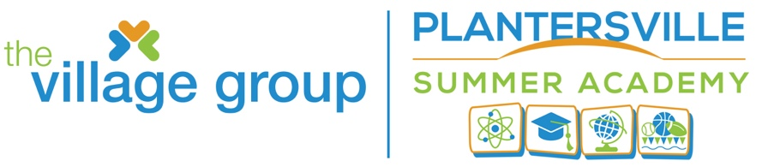

2022 Student Registration, page 1/3 Date:

CHECK ONE
Plantersville Summer Academy
Plantersville Enrichment Academy, After-School
Summer Bridge Program (PES Students, Only)
(Please complete the entire registration form; incomplete applications will delay processing and possibly deny admittance into program)

Last Name First Name M.I.

Grade: (for 2020-21 school term) Date of Birth

School attended during 2021-22 school term

IEP Submitted: Yes No

T-Shirt Size (Check One) YS YM _YL S_ M L XL XXL
One T-shirt provided; additional T-shirt available for $7.00 and must be prepaid before ordering. List the number of extra shirts

Parent/Guardian: Name Address: Cell: _Home Phone_ Email Address: Emergency Contact 1
Last Name _First Name Primary Phone_ _Secondary Phone_ Emergency Contact 2
Last Name _First Name Primary Phone_ _Secondary Phone_
Physician and Medical Information
Last Name First Name Primary Phone Secondary Phone Preferred Hospital Insurance /Health Coverage(Company) List current medications: List medication allergies List food allergies: List chronic health concerns:

2022 Student Registration, page 2/3

Consent and Releases
General Parental/Guardian Consent: As Parent/Guardian I/WE hereby affirm that the student is in good health and suffers from no illness, disability or condition that requires the taking of medication on a regular basis unless that condition is disclosed and approved by program staff. Furthermore, I have no knowledge of any reason the student cannot participate in vigorous physical activity.
I/We expressively agree to be responsible for any medical bills incurred in the treatment of any illness or accident. In the event of any such accident or injury, I /We hereby consent to allowing any of the program supervisors to procure any medical treatment deemed advisable on behalf of your child or ward without prior consent.
I/WE understand that, as a condition of admittance as program participant, I/We, on behalf of all parents and guardians, and on behalf of the student, hereby release The Village Group and its affiliated programs, and all other employees or agents of The Village Group from any and all liability from injury or illness, mental or physical, suffered by the program participant during or related to the program, unless caused by a willful act or gross negligence by the person or entity against whom the claim is made

Medical Release: As Parent/Guardian I/We hereby give permission to The Village Group staff/volunteer to proceed with emergency treatment in the event of accidental injury or illness provided of the immediate family or listed emergency contacts cannot be reached.

Photo Release: I further authorize The Village Group, its affiliates, its successors or assigns, the right to take photographs of my child/ward for marketing and other purposes, as it deems appropriate.

Student Name:

Parent/Guardian (Print):

Parent/Guardian (Signature):

Date:

OFFICIAL USE ONLY

Registration Tuition BB Camp _SWIM Camp

Payment Method Staff Signature

2022 Student Registration, page 3/3

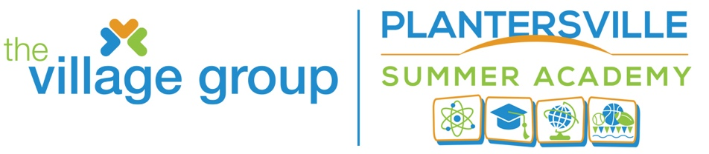

STUDENT RECORD RELEASE FORM
The purpose of the Federal Educational Rights and Privacy Act of 1974 is to protect the privacy of information concerning individual students by placing restrictions on the disclosure of information contained in a student’s education records. By signing below, I hereby authorize Georgetown County School District to release my education records (individuals age 18 and older) or the education records of my child, as described below:

Student’s Name ____________________________________________________________
Date of Birth ______________________________________________________________

I, as an eligible student or parent/guardian authorize Georgetown County School District to release my/my child’s entire educational record.
OR
I, as an eligible student or parent/guardian authorize Georgetown County School District to release only the portions of my/my child’s educational record as listed below:

Health and Immunization Records (including hearing and vision screenings)
Report Cards
Testing Information
Discipline Records
Special Education Records
Other:

Individual(s)/Organization(s)/Agency(ies) to Whom Records May Be Disclosed:

The Village Group

Purpose of Disclosure: To obtain, thru power school and local school officials, student level participation (attendance), testing information, and report cards.

Signature of Parent/Guardian or Eligible Student Date

I am the (check one) Return to: Queen D. Funnye, Program Director
( ) Student The Village Group/Village Academies
( ) Parent Post Office Box 700
( ) Legal Guardian Georgetown, SC 29442
( ) Surrogate Parent academy@thevillagegroup.org
( ) Foster Parent 843-340 3628

